**Green Campus Clean campus Cell**



**GREEN CAMPUS CLEAN CAMPUS CLUB REPORT 2015-2016**

|  |  |  |
| --- | --- | --- |
| Convener | Sri. N.P. Mohamed Jaish | C:\Users\user\Desktop\Mohamed Jaish-Photo.jpg |
| Joint Convener | Sri. A. Jahfar | C:\Users\user\Desktop\Jhafar sir-Photo.jpg |
| Student Co-Ordinator | Anjali. A.S | C:\Users\user\Desktop\attachments\Anjali.jpg |

Club members planted Arya vep and Chembaratti in different locations of the campus on 15.November 2015

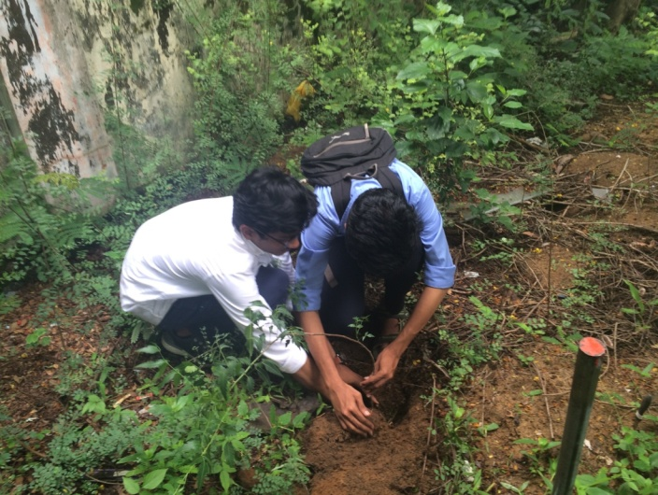 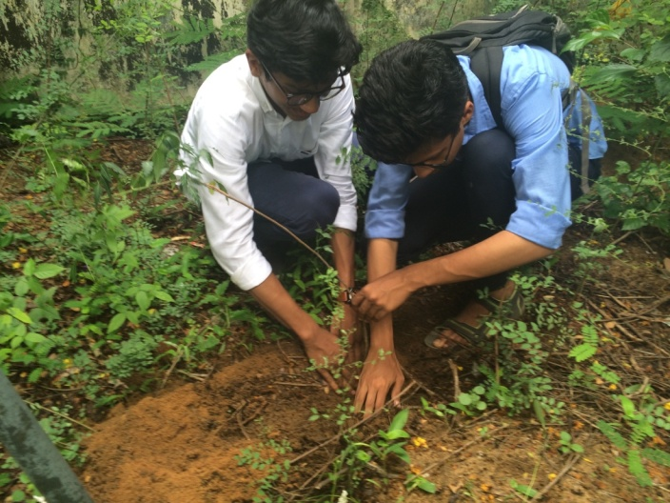

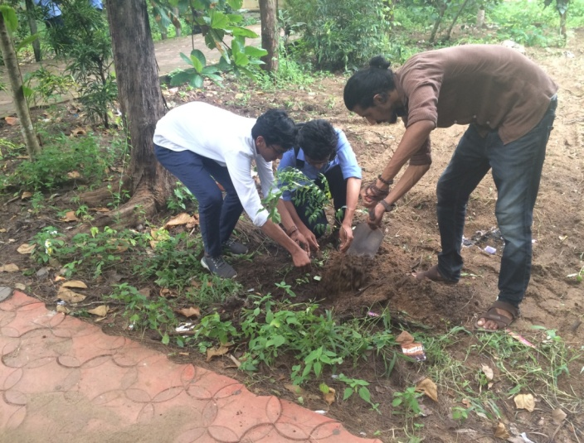 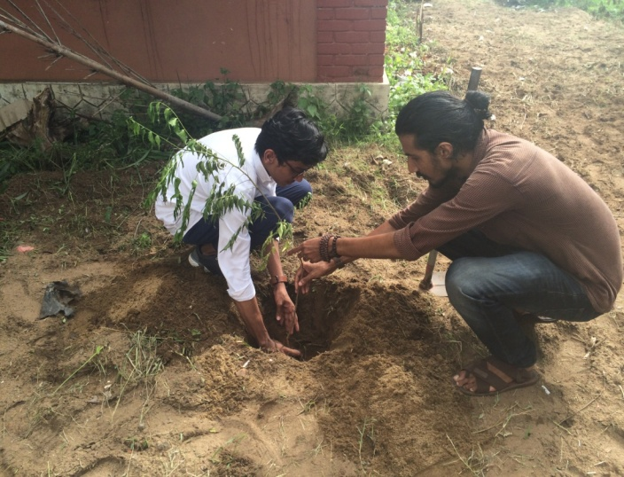

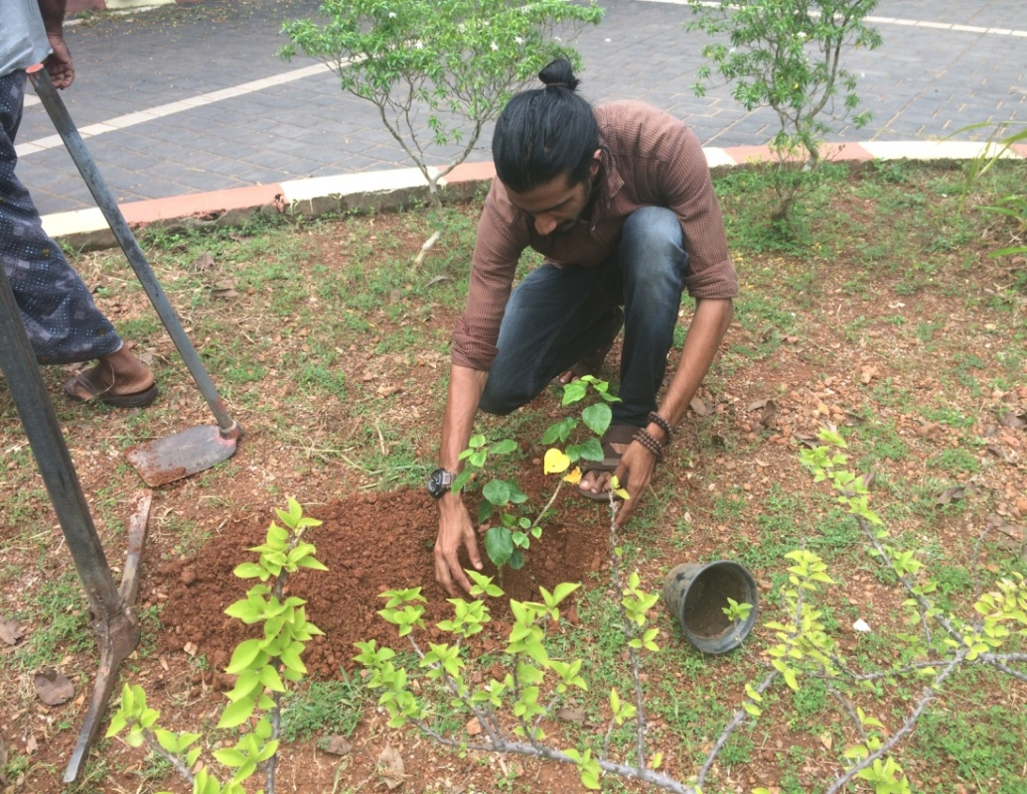

Club Members cleaned the MSK auditorium on January 2016

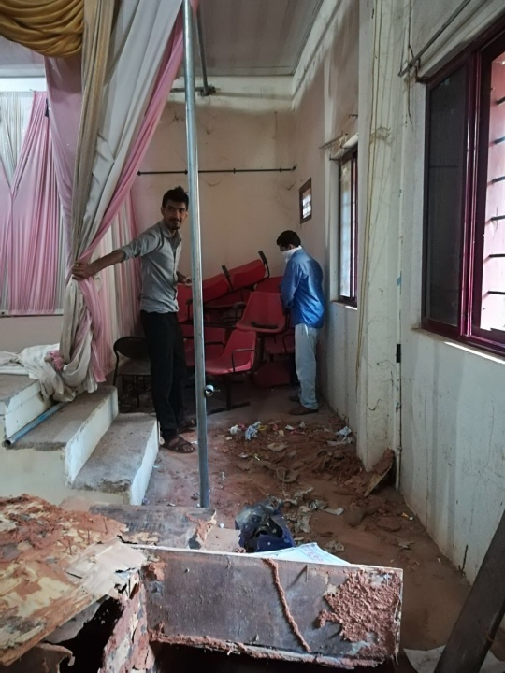 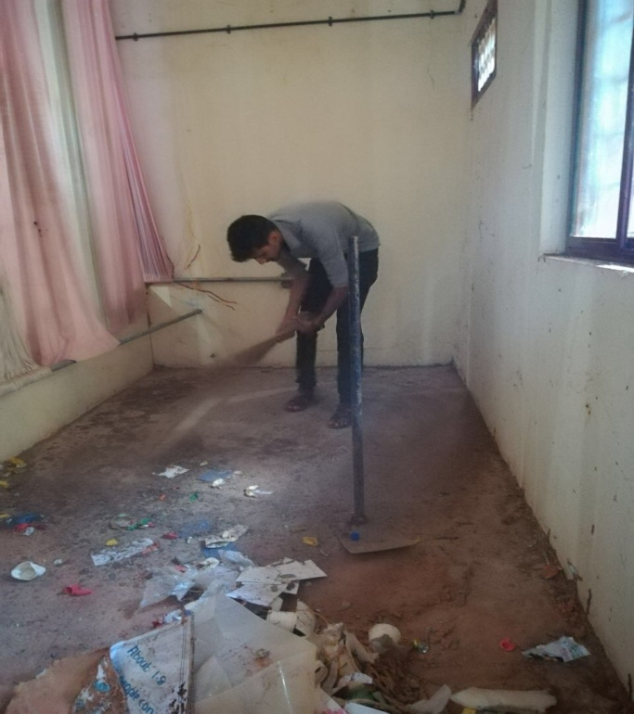

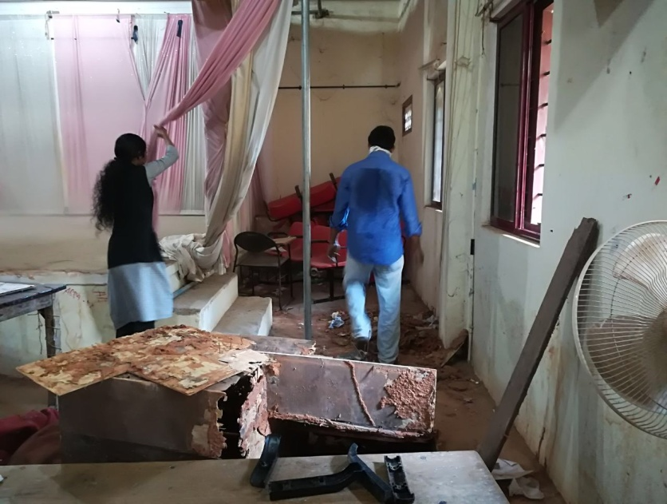

**Club members planted banaa plants and started vegetable farming in waste dumping area of the college on 14th March 2016**

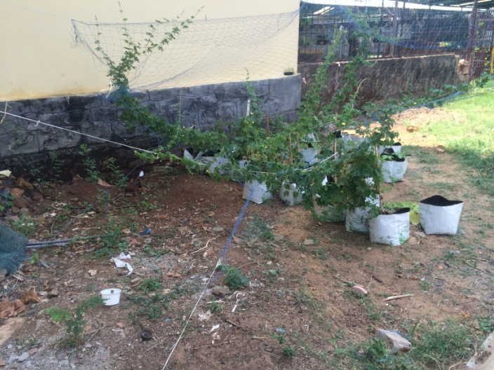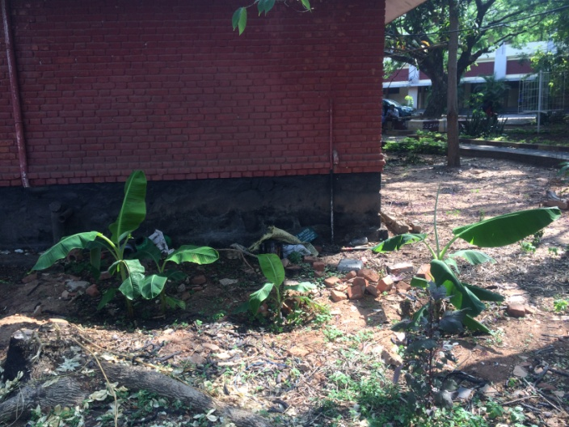

**Students cleaned and beautified the campus on 25th January 2016**

